1.
2.
3.
4. prove that
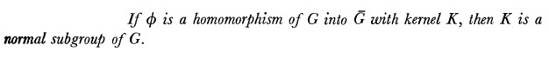
5.
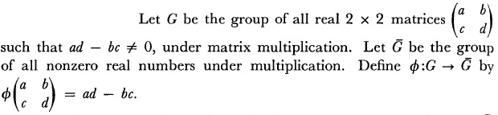
Verify whether is a homomorphism.
6.
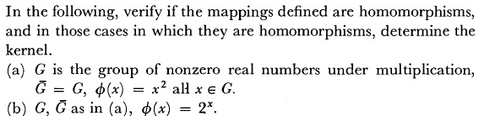
7.
8.
